Path Planning for Robot

1.Path Planning Algorithm

1.1Find the Inclination coordinates for Robot Link provided the nearest segment

The robot link must start from the starting node and should reach the destination node as per the diagram below

At each step the robot link checks whether its length is parallel to the nearest segment in the ideal path

The inclination angle ‘a’ for x axis and y axis for the robot link is obtained by the slope of the nearest segment

Let AB be the nearest segment with coordinates A(x1,y1) and B(x2,y2)

Slope of nearest segment S = tan (a) = (y2-y1)/(x2-x1)

tan (a) = S1 $-x^{2}$

a = $\tan^{-1}(S)$

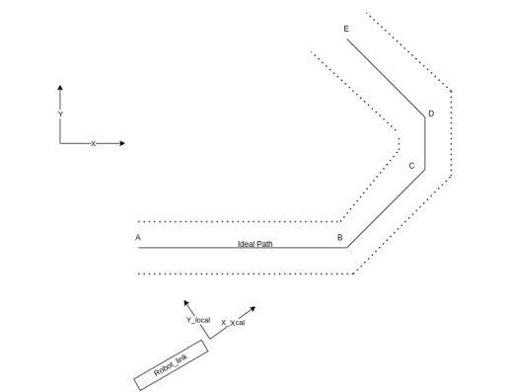

let $x_{c}$ and $y_{c}$ be center of the robot link

the new four coordinates ($X_{i}, Y_{i}$) (i = 0 to 4)for the robot link is calculated by the following equation

X1 = x1-xd; Y1 = y1+yd;

X2 = x2-xd; Y2 = y2+yd;

X3 = x1+xd; Y3 = y1-yd;

X4 = x2+xd; Y4 = y2-yd;

x1 = $x_{c}$ +*cos*(a)\*(len/2); y1 = $y_{c}$ +*sin*(a)\*(len/2); (len-length of the robot link)

x2 = $x_{c}$ +-*cos*(a)\*(len/2); y2 = $y_{c}$-*sin*(a)\*(len/2);

The above new four coordinates ($X_{i}, Y_{i}$) gives the position of robot inclined parallel to the nearest segment

1.2Find the nearest segment

At each step when the robot moves it checks the 2 distances called as dist1 and dist2

dist1 = distance between the points of current segment

dist2 = distance between the first point of current segment and center point of robot

1. if dist1 is greater than dist2 the robot should move with same inclination of current segment
2. if dist2 is greater than dist1 the robot reaches the next segment so it should change the inclination of the next segment

and dist1 and dist 2 be recalculated